BIOS LAB

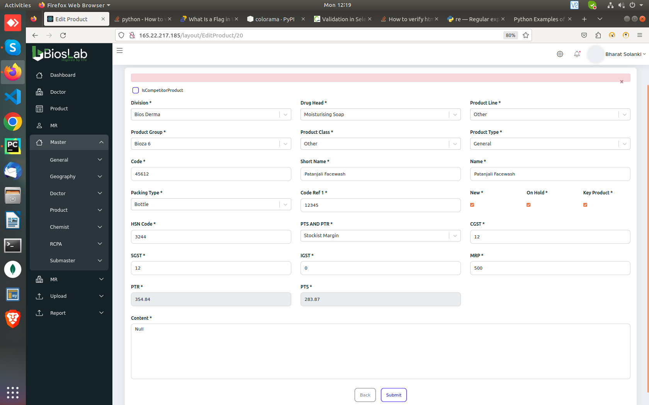

Edit product is not working, clicking submit without changing any values throws this error.

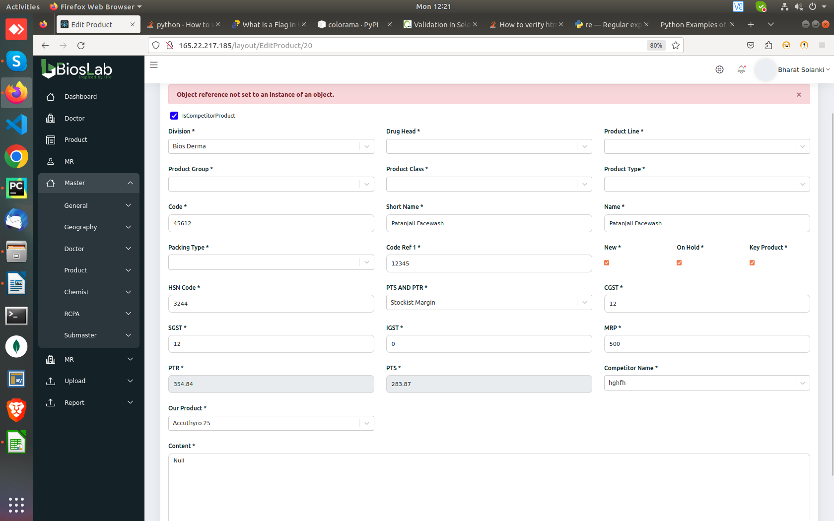

Adding competitor in Edit product doesn’t work.

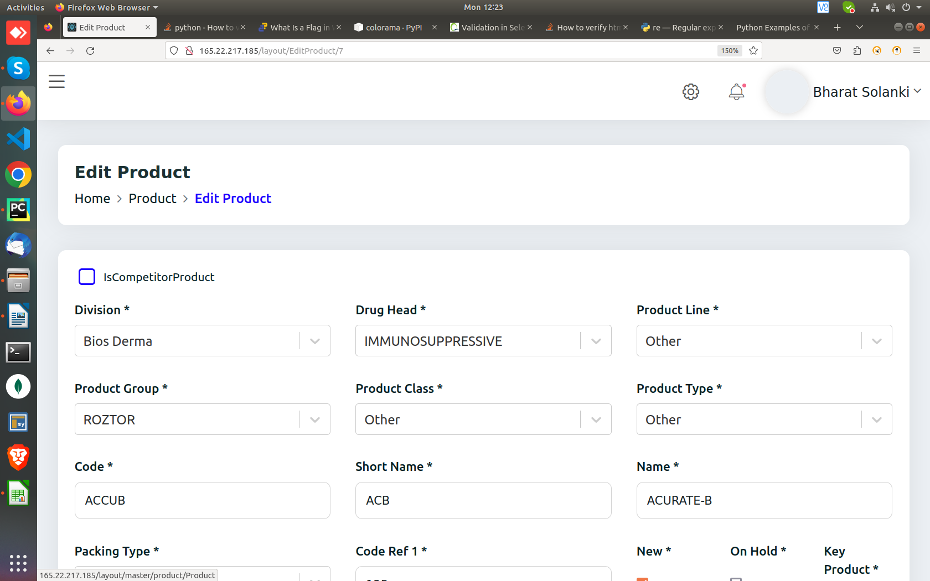

Clicking “Product” in edit product navigation options ( Home > **PRODUCT** > Edit Product) lands on a blank page

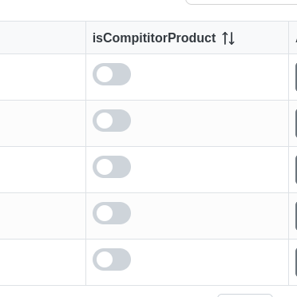

IsCompititorProduct button is not working in Edit product, as well as in